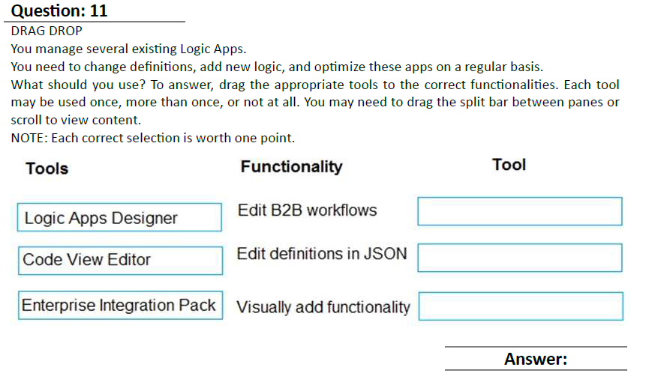



**Question: 4**

HOTSPOT

You are developing a data storage solution for a social networking app.

The solution requires a mobile app that stores user information using Azure Table Storage.

You need to develop code that can insert multiple sets of user information.

How should you complete the code? To answer, select the appropriate options in the answer area.

NOTE: Each correct selection is worth one point.





**Question: 5**

You are developing a software solution for an autonomous transportation system. The solution uses

large data sets and Azure Batch processing to simulate navigation sets for entire fleets of vehicles.

You need to create compute nodes for the solution on Azure Batch.

What should you do?

A. In Python, implement the class: TaskAddParameter

B. In Python, implement the class: JobAddParameter

C. In the Azure portal, create a Batch account

D. In a .NET method, call the method: BatchClient.PoolOperations.CreateJob

**Answer: D**

**QUESTION 4**

Note: This question is part of a series of questions that present the same scenario. Each question in the series contains

a unique solution Determine whether the solution meets the stated goals.

You need to meet the vendor notification requirement.

Solution: Configure notifications in the Azure API Management instance.

Does the solution meet the goal?

A. Yes

B. No

Correct Answer: B

Use a custom outbound Azure API Management policy.

**QUESTION 6**

HOTSPOT

You need to configure retries in the LoadUserDetails function in the Database class without impacting user experience.

What code should you insert on line DB07?

To answer, select the appropriate options in the answer area;

NOTE: Each correct selection is worth one point.

Hot Area:

Latest



**QUESTION 11**

You need to resolve the Policy Loss issue.

What are two possible ways to achieve the goal? Each correct answer presents a complete solution.

NOTE: Each correct selection is worth one point.

A. Add an Azure Event Hub. Send the policy to the event hub. Configure the Policy service to read actions from the

event hub.

B. Add an Azure Service Bus queue. Send the policy to the queue. Configure the Policy service to read actions from the

queue.

C. Add an Azure Queue storage queue. Send the policy to the queue. Configure the Policy service to read actions from

the queue.

D. Add an Azure Service Bus topic. Send the policy to the topic. Configure the Policy service to read actions from the

topic.

**Correct Answer: BD**



**QUESTION 12**

You need to implement the purchase requirement.

What should you do?

A. Use the Bot Framework REST API attachment operations to send the user\\'s voice and the Speech Service API to recognize intents.

B. Use the Direct line REST API to send the user\\'s voice and the Speech Service API to recognize intents.

C. Use the Speech Service API to send the user\\'s voice and the Bot Framework REST API conversation operations to recognize intents.

D. Use the Bot Framework REST API conversation operations to send the user\\'s voice and the Speech Service API to recognize intents.

**Correct Answer: D**

**QUESTION 13**



You need to support the requirements for the Shipping Logic App.

What should you use?

**Options:**

A. Azure Active Directory Application Proxy

B. Point-to-Site (P2S) VPN connection

C. Site-to-Site (S2S) VPN connection

D. On-premises Data Gateway

**Answer: D**

Question 5

You are writing code to create and run an Azure Batch job.

You have created a pool of compute nodes.

You need to choose the right class and its method to submit a batch job to the Batch service.

Which method should you use?

**Options:**

A . J o b O p e r a t i o n s . E n a b l e J o b A s y n c ( S t r i n g ,

IEnumerable<BatchClientBehavior>,CancellationToken)

B. JobOperations.CreateJob()

C. CloudJob.Enable(IEnumerable<BatchClientBehavior>)

D. JobOperations.EnableJob(String,IEnumerable<BatchClientBehavior>)

E. CloudJob.CommitAsync(IEnumerable<BatchClientBehavior>, CancellationToken)

**Answer: E**

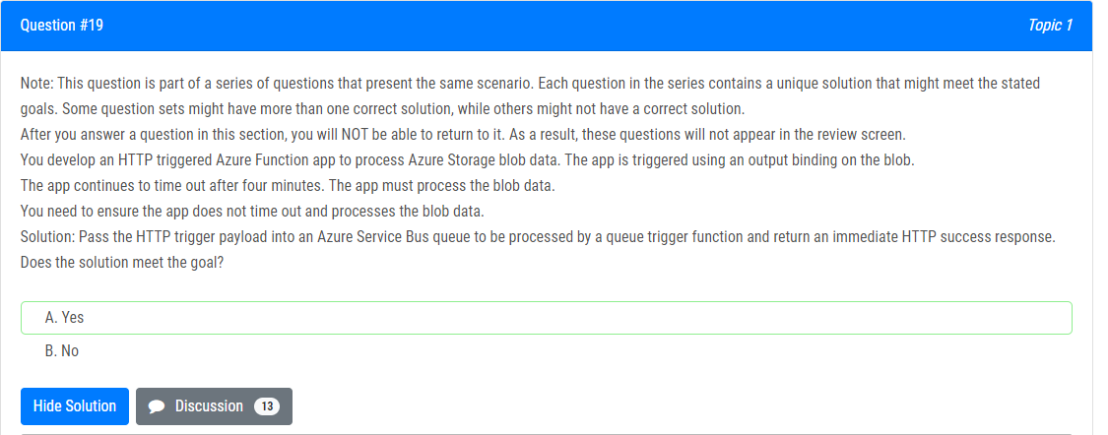

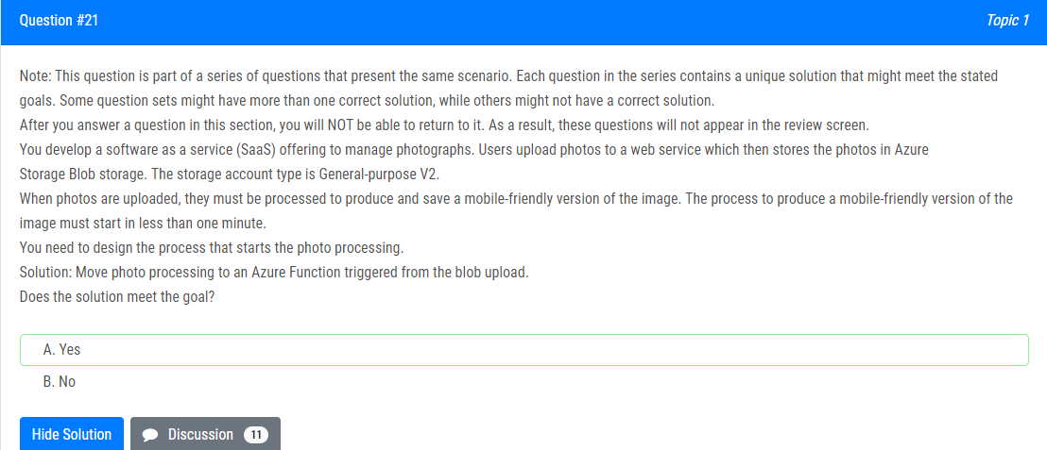

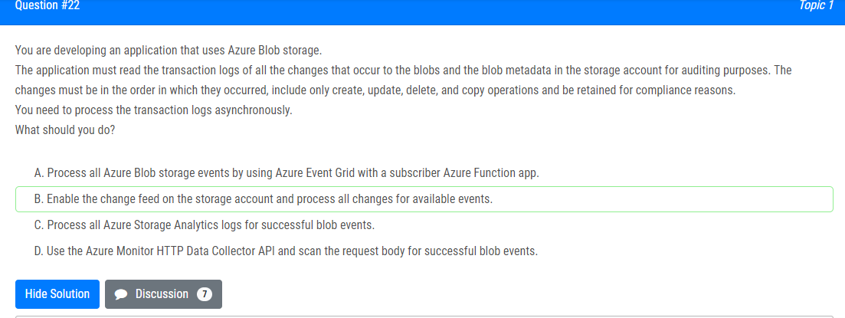

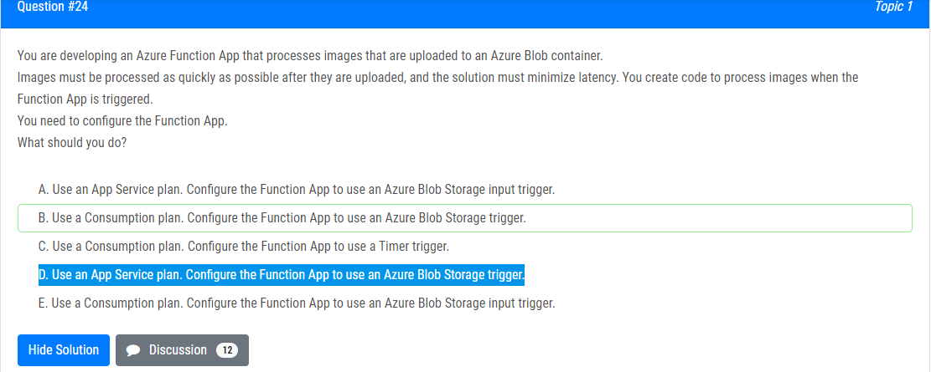

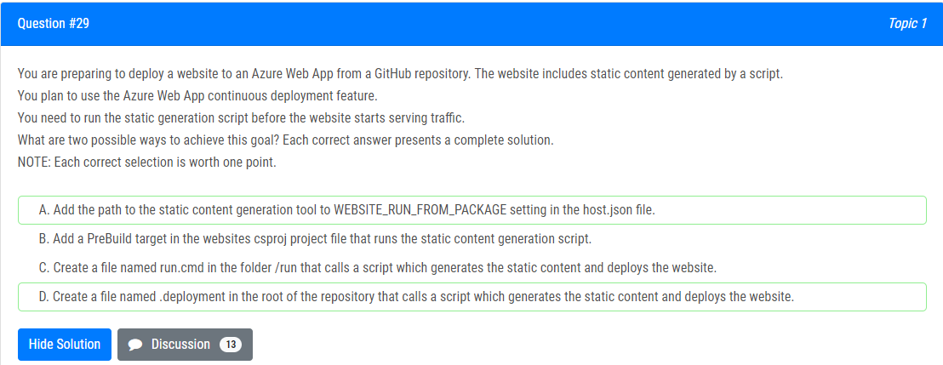

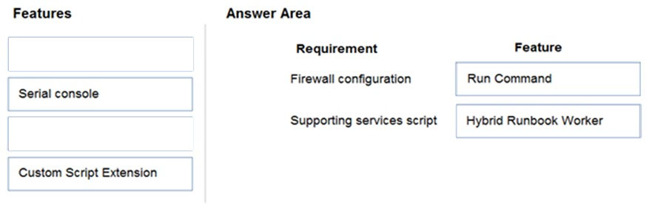

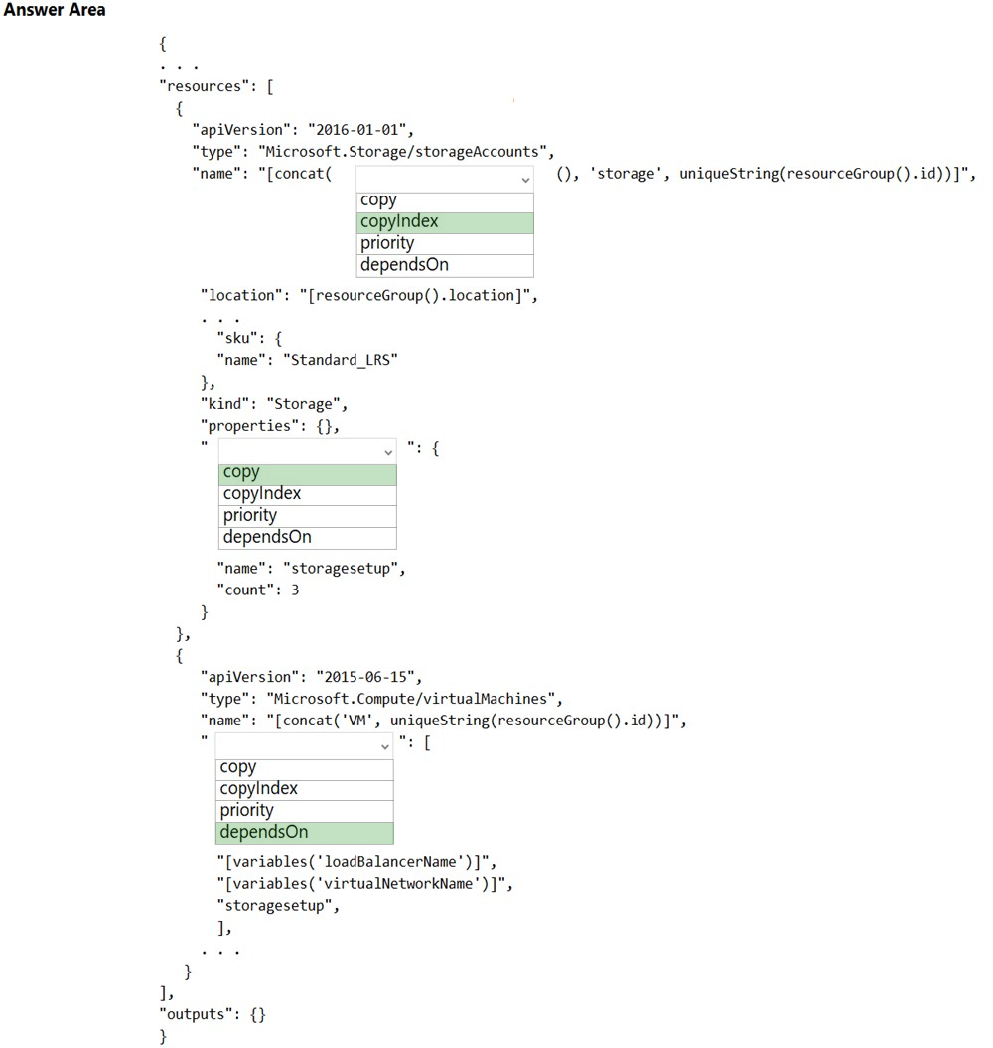

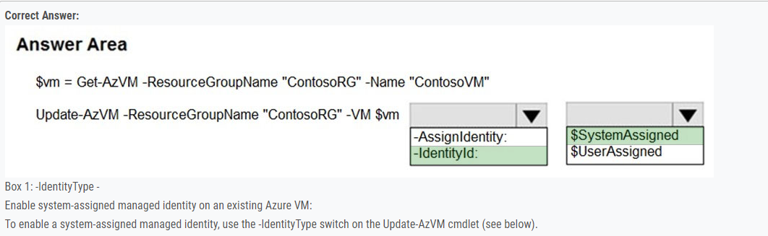

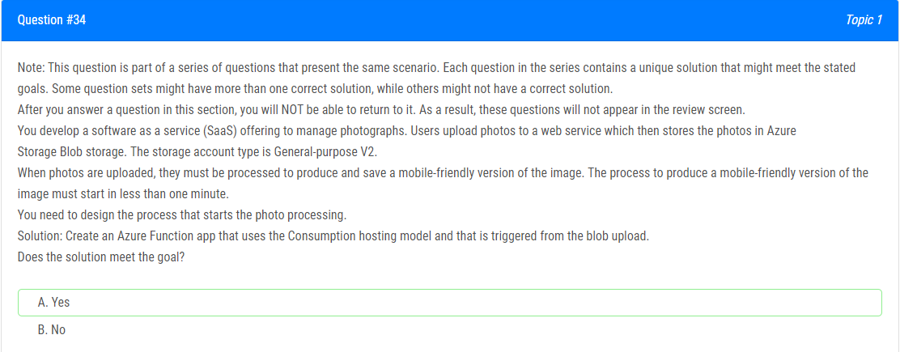

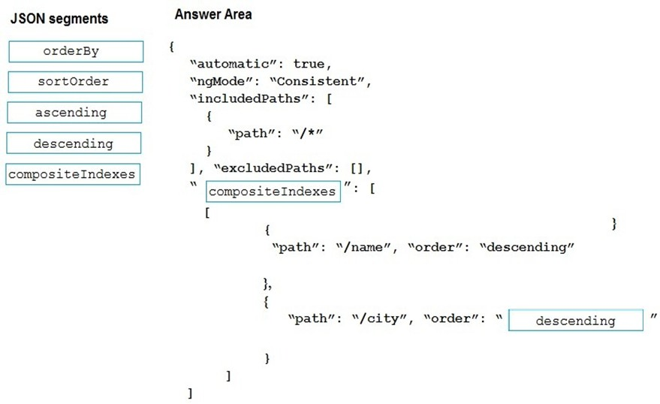

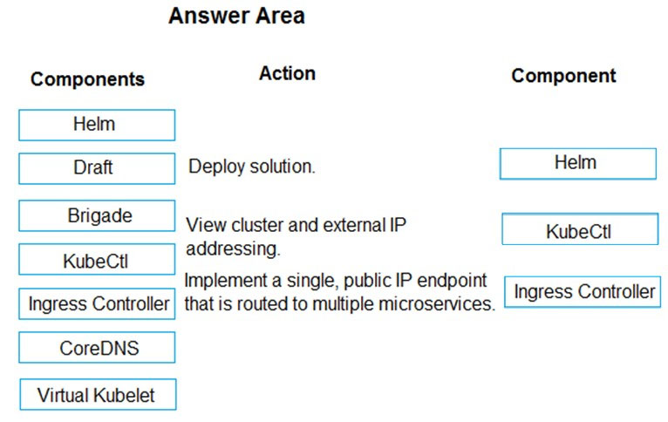

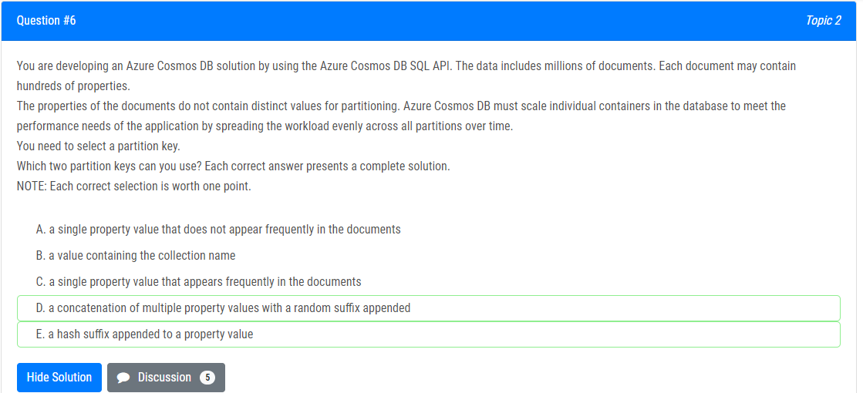

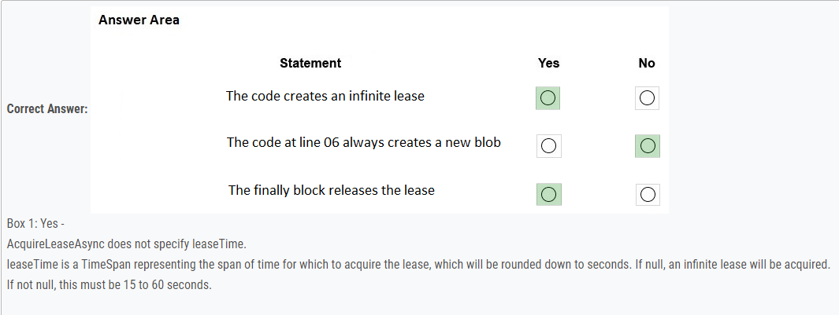

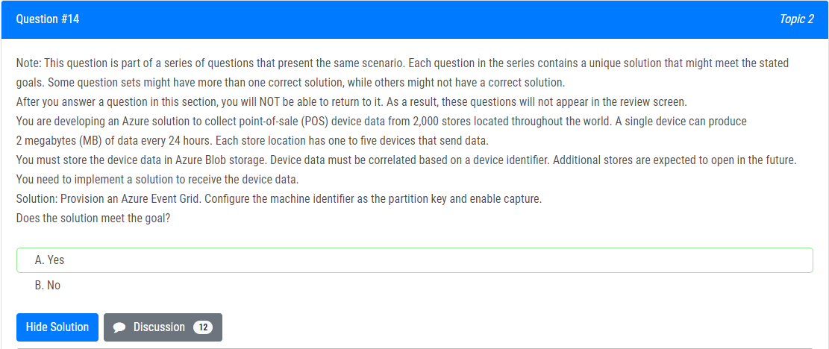

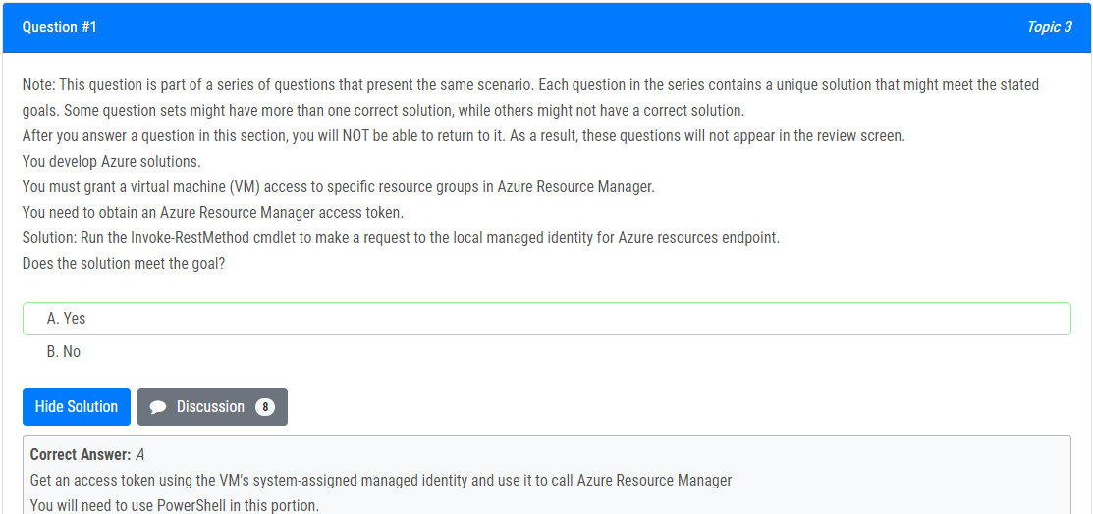

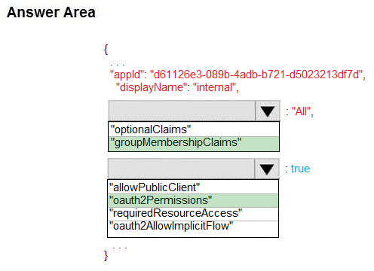

**Oauth2AllowImplicitFlow**

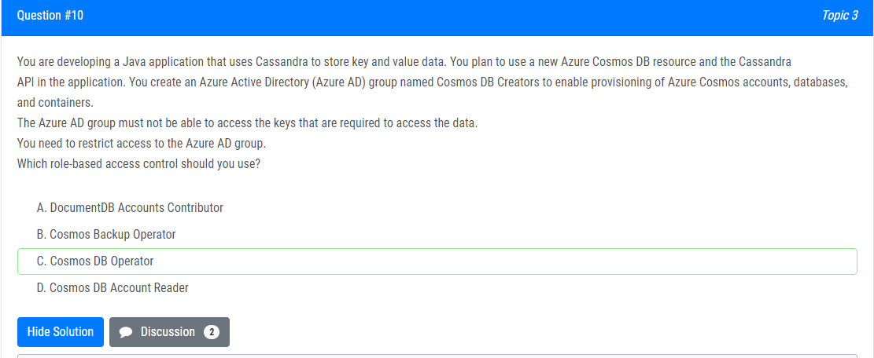

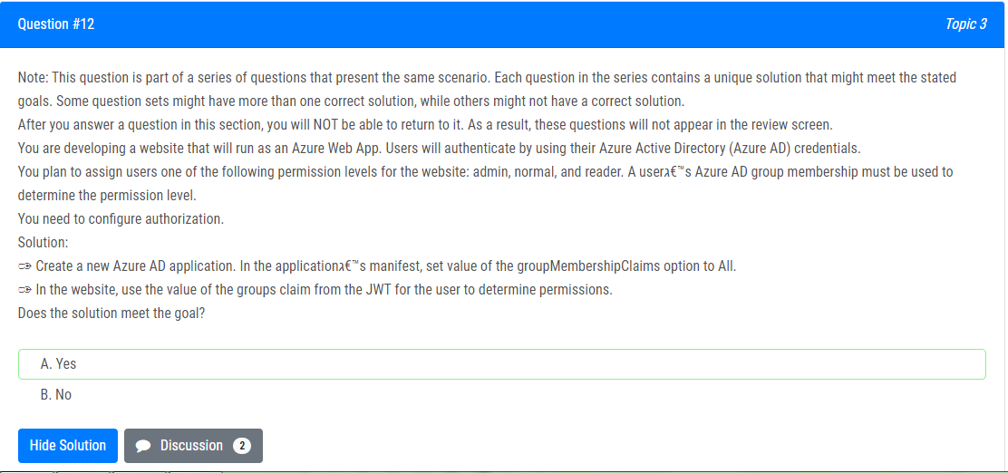

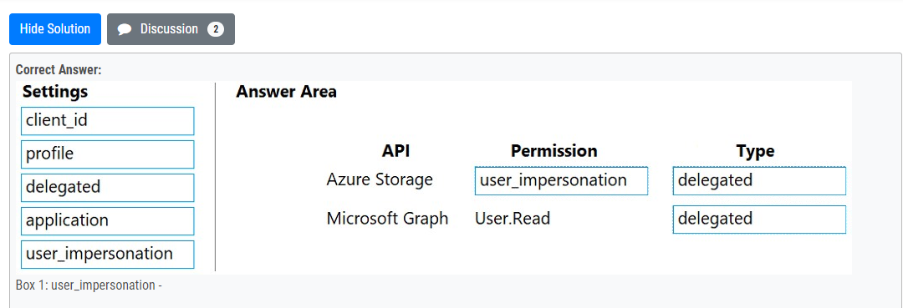

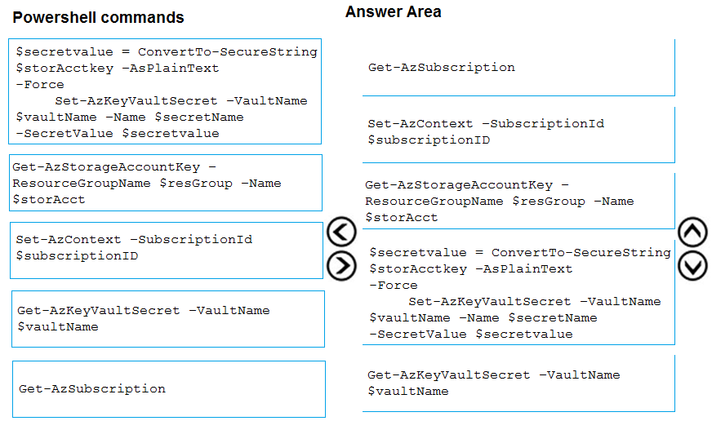

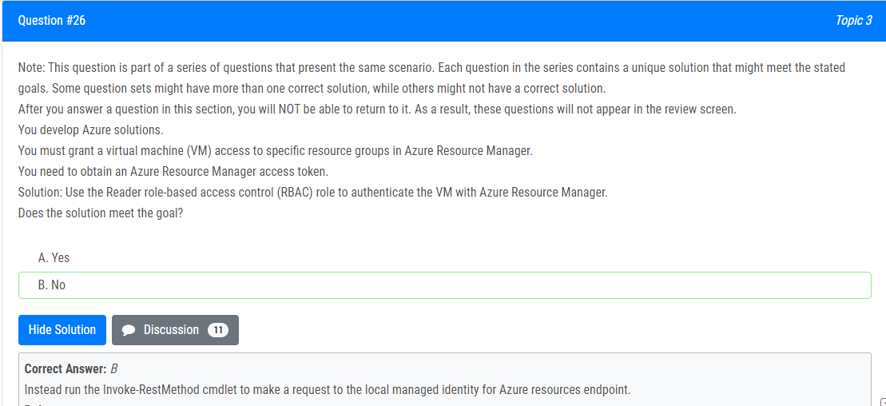

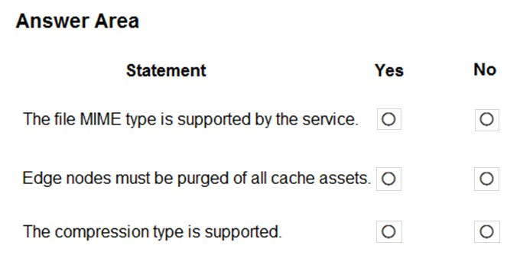

**Answer: Yes, No, Yes**

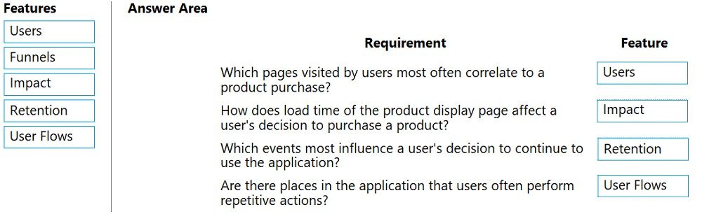

Create Pool

Create Job

For loop

Create Task

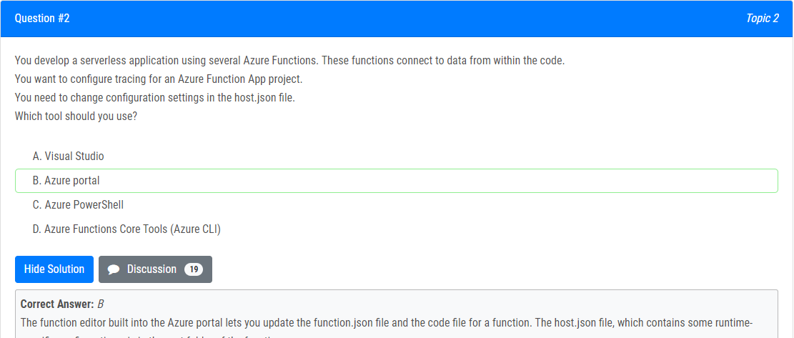

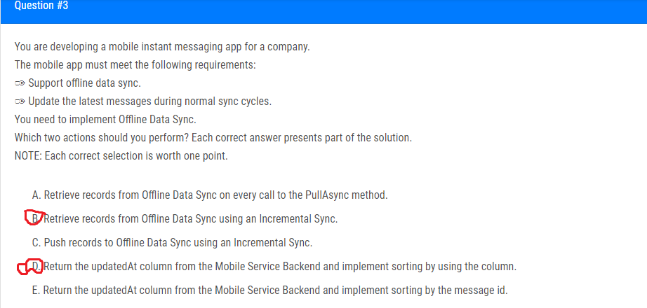

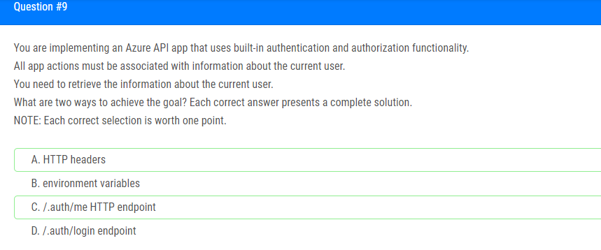

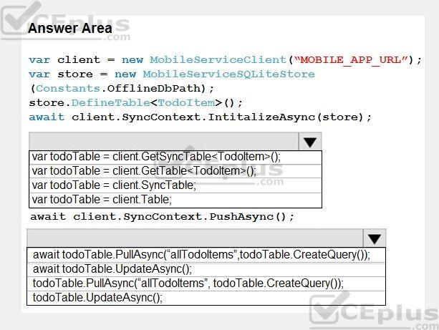

**Answer:**

Box 1: var todoTable = client GetSyncTable<TodoItem>()

Box 2: await todoTable.PullAsync("allTodoItems",todo.Table.CreateQuery());

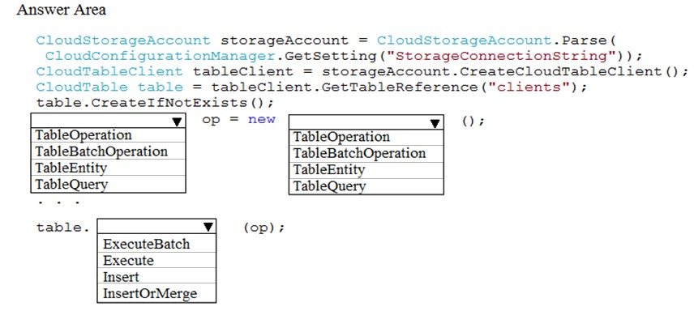

Box 1, Box 2: TableBatchOperation

Box 3: ExecuteBatch –

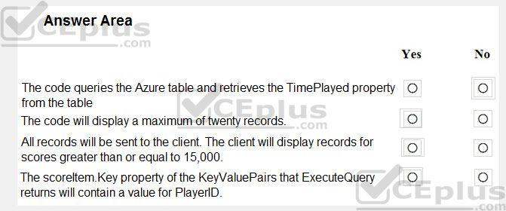

**Answer: No, Yes, No, Yes**

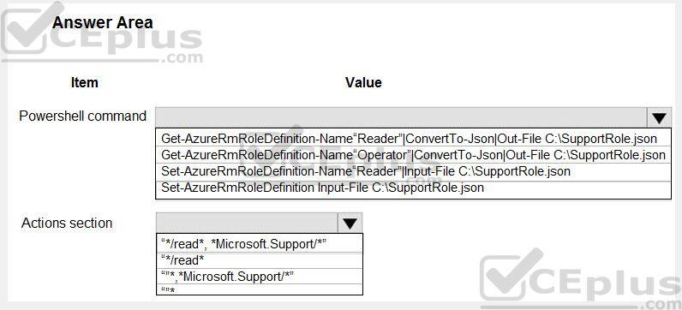

Box 1: Set-AzureRmRoleDefinition Input-File C:\SupportRole.json

Box 2: "*/read*."* Microsoft.Support/*"

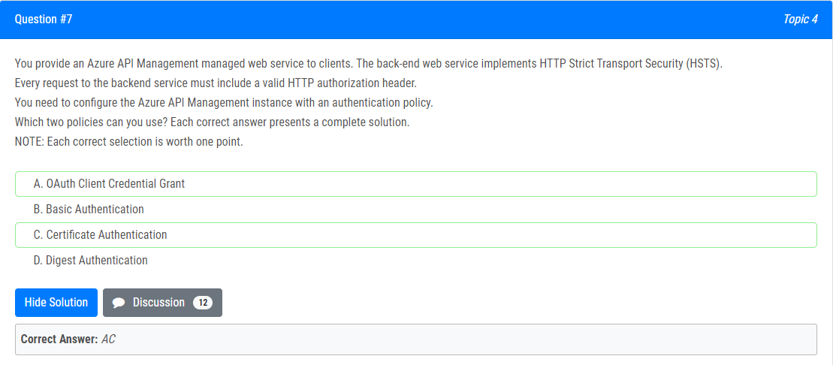

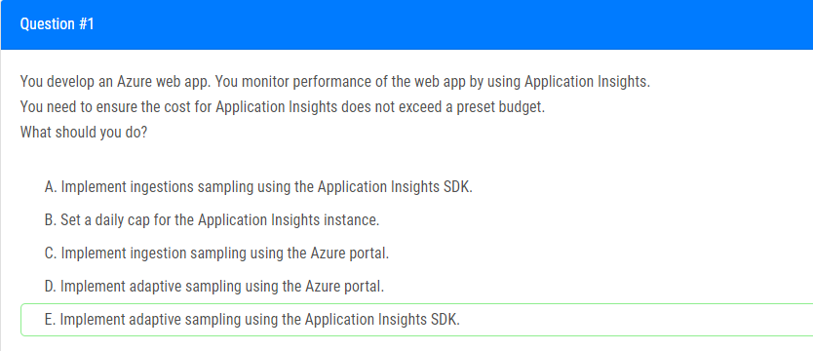

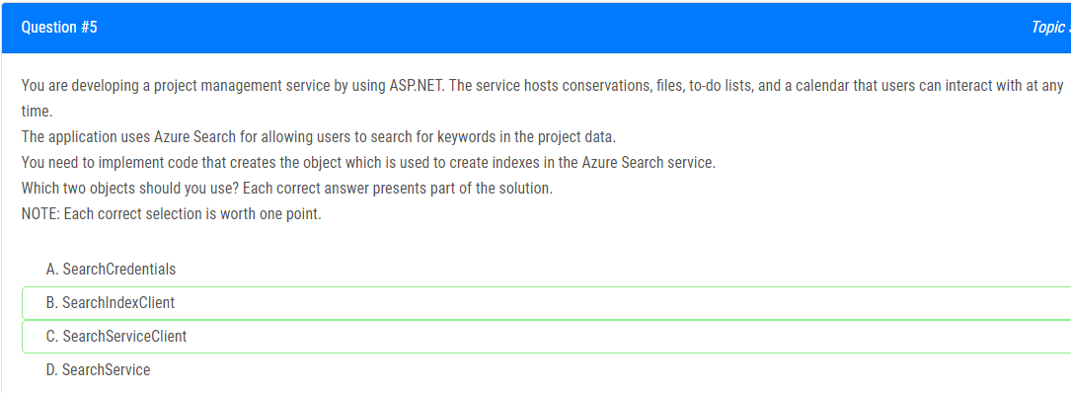

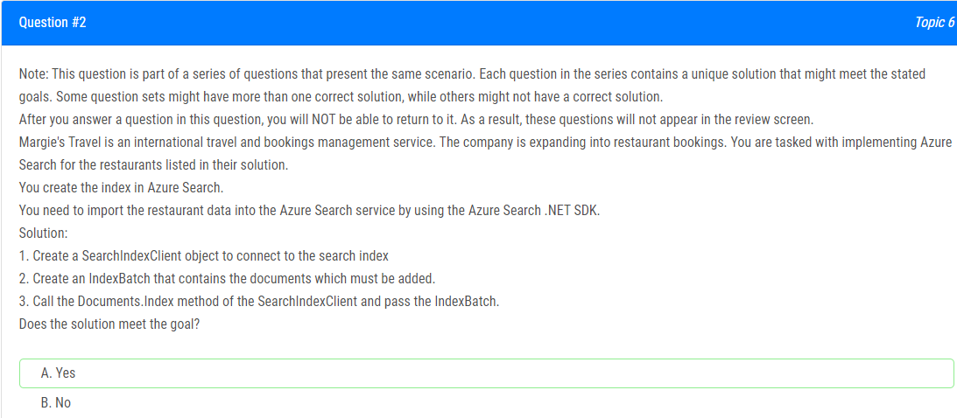

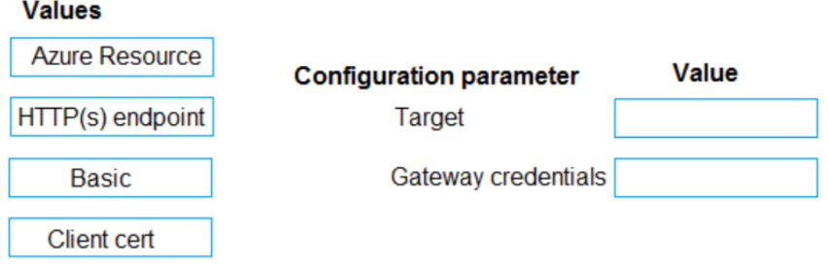

**Answer:** Https Endpoint and Client Cert

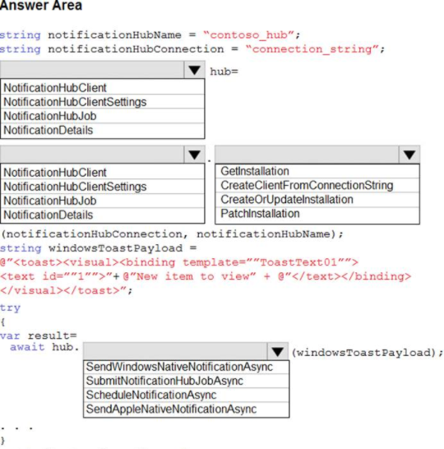

**Answer:**

Box 1: NotificationHubClient -  
Box 2: NotificationHubClient -  
Box 3: CreateClientFromConnectionStrin

Box 4: SendWindowsNativeNotificationAsync

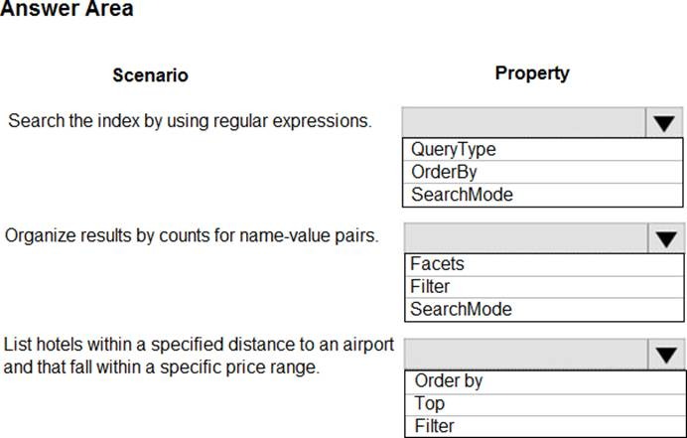

Box 1: QueryType –

Box 2: Facets –

Box 3: Filter –

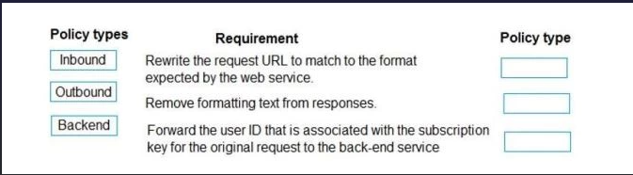

**Inbound, Outbound, Backend**

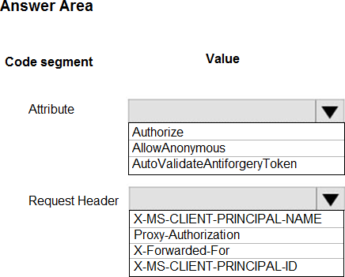

Box 1: Authorize -  
Box 2: X-MS-CLIENT-PRINCIPAL-NAME

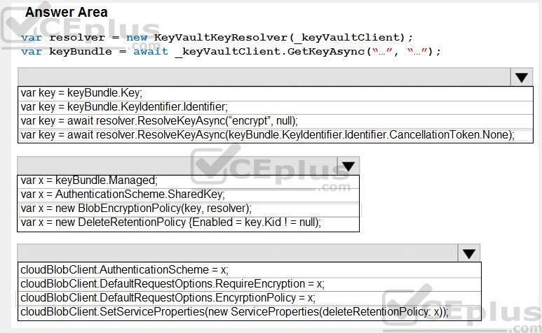

Box 1: var key = await Resolver.ResolveKeyAsyn(keyBundle,KeyIdentifier.CancellationToken.None);  
Box 2: var x = new BlobEncryptionPolicy(key,resolver);

Box 3: cloudblobClient. DefaultRequestOptions.EncryptionPolicy = x;

